Launch one EC2 and install Jenkins
Launced ec2 and installed Jenkins
sudo apt updatev -y
sudo apt update -y
sudo yum update -y
sudo yum install java-17-openjdk -y
sudo wget -O /etc/yum.repos.d/jenkins.repo https://pkg.jenkins.io/redhat-stable/jenkins.repo
sudo yum install jenkins -y
sudo systemctl start jenkins
cat jenkins
sudo yum install jenkins -y
sudo rpm --import https://pkg.jenkins.io/redhat-stable/jenkins.io-2023.key
sudo yum install jenkins -y
sudo systemctl start jenkins
sudo systemctl status jenkins'
sudo systemctl status jenkins
sudo systemctl enable jenkins
sudo systemctl start jenkins
sudo systemctl status jenkins

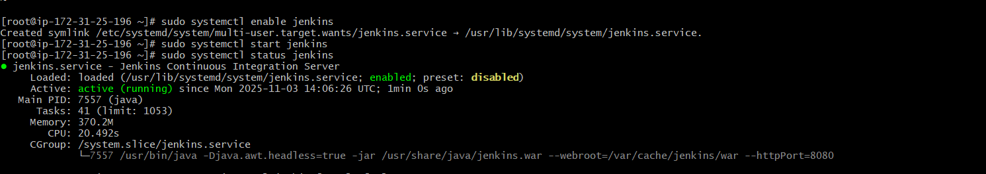
- setup apache tomcat on ubuntu virtul.machine

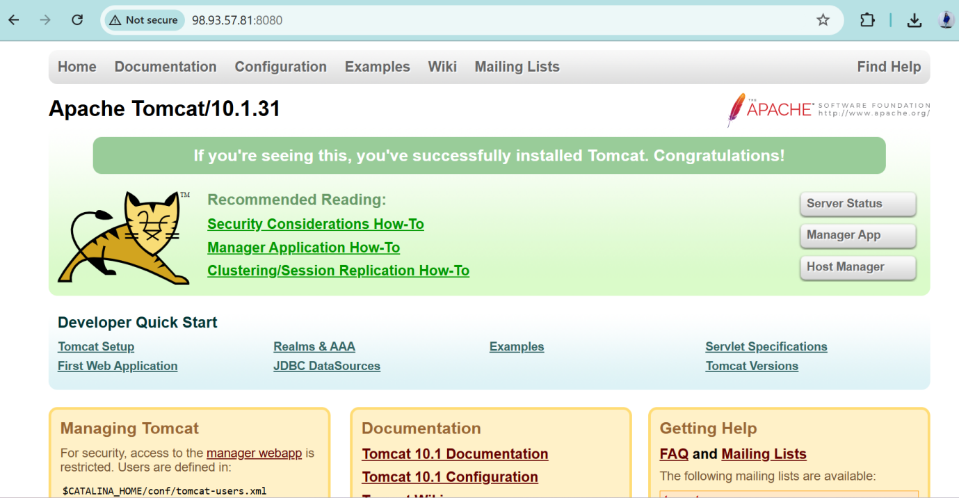2. Setup the docker desktop on your local windows
Open powershell
Wsl --install
Wsl --list --verbose
Download the docker in windows
Restarted the system
And setup the docker
